
North Talk

FULHAM NORTH PRIMARY SCHOOL

Cheadle Street, HENLEY BEACH SA 5022
Phone 8356 9272 Fax 8235 1301

www.fulnorthps.sa.edu.au


Term 3

Week 1

26 July 2018

★   Dates to remember   
Monday 30 July | Bunnings excursion | Rooms 1 & 2
Wednesday 1 August | Giant Soup day | Whole school
Thursday 2 August | Assembly – Run by Room 16 | Gym at 2.25pm
Friday 4 August | Maritime Museum excursion | Years 4 & 5
Tuesday 7 August | Finance Committee meeting | Staff room at 5pm
Wednesday 8 August | Knockout Boys Football | Fulham North PS
Thursday 9 August | Knockout Girls Soccer | Collins Reserve
Week of 13 August | Book Week – ‘Find Your Treasure’ | Whole School
Monday 13 August | Governing Council meeting | Staff room at 7pm
Thursday 16 August | Assembly – Run by Room 23 | Gym at 2.25pm
Tues 21 Aug & Wed 22 Aug | Lab on Legs Incursion | Years 4 & 5
Wednesday 29 August | Nude Food Day | Whole School
Thursday 30 August | Assembly – Run by Room 17 | Gym at 2.25pm
Monday 3 September | Partnership Professional Development Day | School Closure
Tuesday 4 September | Royal Adelaide Show Day | School Closure
Wednesday 5 September | Open Morning | Staff room at 9.30am
Tuesday 11 September | District Athletics Day | Henley Oval, Cudmore Tce
Thurs 20 Sept & Fri 21 Sept | Camp – Year 3

FROM THE PRINCIPAL
Hello, I’m the newly appointed Principal, Marcus Knill. It is an absolute privilege to accept this role for the next six months. Having attended Fulham Gardens Primary School and Henley High School in the 70s and 80s, it feels like I’m coming home. I have received a warm welcome by the students, staff and you, the parents, carers and community members. Sincere thanks for this as I settle in.

In my short time here, I have developed a strong sense of community pride in our school. This is one of the foundations that continuously builds a great school.

I have held a number of leadership roles in public education since my beginning teaching days in Ceduna in the 90s. Currently, I am in the third year of a five year appointment as a Principal Consultant in the Department, which has been put on hold for the next six months whilst I take up this position. As a Principal Consultant, I worked with 22

primary, secondary and special education schools to support leadership teams in school improvement in the Le Fevre Peninsula and West Torrens areas. Before this time, I
was the Principal at Northfield Primary School from 2011-2015.

I look forward to working with our leadership team, Kristian, Briony and Sally to continue the high standards of achievement at Fulham North for the remainder of 2018.

If I haven’t met you yet, I look forward to doing so and please don’t hesitate to make a time to see me should you wish to discuss any aspect of your child’s education.

Kind regards,
Marcus Knill

SCHOOL NEWS
CATHERINE HOUSE
DONATIONS NEEDED
Dear families and community members,
As a whole staff we have decided that in Term 3 we will have a focus of raising funds and awareness to a very worthy Adelaide cause – Homeless Women at Catherine House.
What is Catherine House?

Catherine House provides supported accommodation services to women experiencing homelessness in South Australia, who are 18 years and older, and unaccompanied by children. Catherine House was founded 30 years ago and over subsequent years the organisation has both grown and refined its model and is now recognised as Adelaide’s only recovery based service for women experiencing homelessness. Catherine House believes that every woman is a woman of potential, with capacity and capability, and the right to the choices that lead to a dignified life. As well as financial donations, the clients at Catherine House are always in need of various items to assist them or as they leave to help them get “back on their feet”.
We are asking for our community to please donate something from the list below to the front office and place in the baskets provided.
- Sanitary Pads- All varieties
- Shampoo and Conditioner
- Face Cleanser
- Face Moisturiser
- Face Washers/Shower Sponge
- Umbrellas
- Gift Cards- Target, Kmart, Coles, Big W
- Travel Mugs
- New Dressing Gowns
- New Socks
- Internet Dongles
- Washing Baskets
- Cleaning Products
- Calico Bags
- Plastic Storage Tubs
- Non-Perishable Food
- Single or Queen bed covers
- New Pillow Cases
- New Pillow
- New clothes
Thank you very much for your support on this.
Irene Gray

GIANT SOUP DAY
On Monday and Tuesday of Week 2, classes will harvest their vegetable plots in preparation for a giant soup lunch on Wednesday, 1 August. The Staff Environmental Group, Environment Kids and parent helpers will cook up:
- Pumpkin soup
- Sweetcorn and bacon soup
- Minestrone & pasta soup
Every student will receive half a bread roll to accompany their soup (if they wish). Students must bring their own soup mug/cup on the day please. Should students wish to eat more, they should still bring a small packed lunch from home.
Environment Committee

PREMIER’S READING CHALLENGE
Seven weeks to go! Well done to all those students who have completed the Premier’s Reading Challenge for 2018 but is not too late if it hasn’t been completed yet. Students may want to ask their friendly Teacher Librarians for help selecting reading materials they like reading. We are aiming for all students to achieve an award this year.

Room 10
Anjali Beames Rosie Bowes
Kyah Clavell Will Curness
Sophia Eckermann Ruby Henry
Zoe How Brady Smith

Room 11
Aidan Bell Christian Caven
Marni Chandler Jay Chow
Hamysh Delaney Kate Hobson
Nicole Mihnev Oskar O’Callaghan

Room 16
Bianca Barbaro Finley Cleland
Jonathan Devine Smilla Pilekaer-Christensen

Room 19
Levi Barratt Dejan Cvijanovic
Luka Ferguson Riley Moen
Jade Taylor

Room 20
Charli Datson Daniel Gajic
Zac Hilder Andrea Marques-Rondon
Kayla Raymond Halle Tredrea

Room 22
Ella Forrest Edwin Jimmy
Sebastian Tooley Abbie Van Pelt
Zachary Zanker

RAP, RHYME AND RHYTHM 2018
Late last term, parents, staff and students were treated to a magnificent Rap Rhyme and Rhythm performance by our students. Charli Datson kicked off the evening with the humorous rap, ‘The Benefits of the Cucumber’, followed by Year three to seven students reciting a variety of wonderful poems.
Special mention needs to go to the performers who wrote their own poems: Year 3 students Ruby Snowden, Jade Rocca-Day, Sophia Mendoza and Toby Clogg; as well as Bella Black, Zoe How, Joe Bird, Seton Higgins and Jaz Rollison-Henson.
Ryan Grinsted impressed the audience with his heartfelt performance of the Linkin Park rap ‘Somewhere I Belong’. Then the audience were completely blown away by the Year 2 students’ performance of Baker Boy’s Maryuna, choreographed by Bu Mac. Lead rappers, Maryam Mohammed and Zac Mowling, both proved to be exceptional.
The comperes, Ella Yang, Zoe How, Kai Flannigan, Alex Bird and Joe Bird, kept the evening running smoothly and were a pleasure to work with during the rehearsals.
I’m already looking forward to next year’s performance.
Kristin Martin

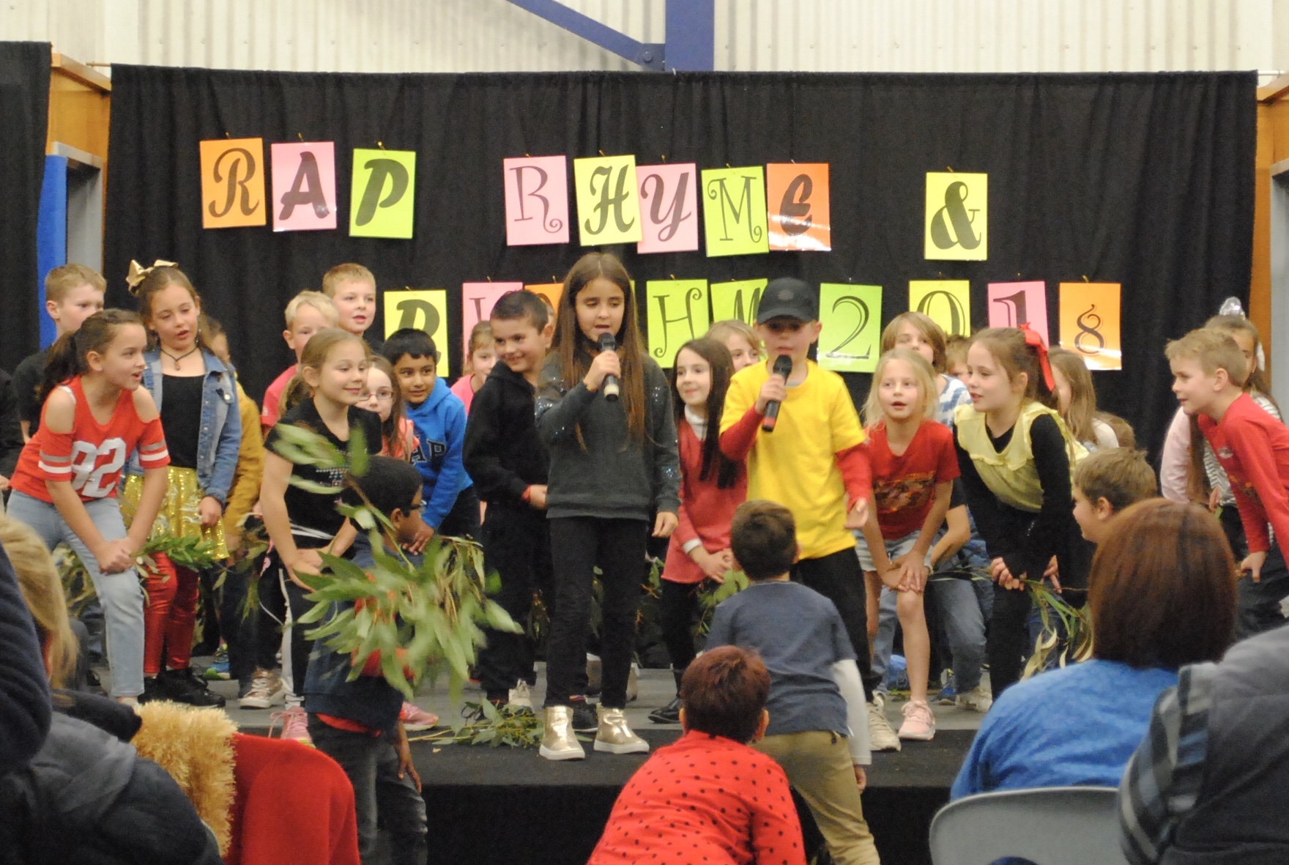
SCHOOL AWARDS
SCHOOL VALUE AWARDS
‘Confidence’
Ben Hayles Koby Owen
Adam Wiertelak Orla McAllister
William King Skyla Hoare
Lachie Gower Ava Turner
Christopher Kosmas Darcy Thurstans
Lochlan Knutson Jasmina Hasancevic-Arevalo
Angelina Garyphalos Andrea Marques-Rondon
Emiliee Hutchins Riley Hansen
Amelia Barbaro

OSHC AWARDS
Liza Westley
Interacting nicely with other OSHC students
Lachlan Gower
Always having a positive attitude when playing soccer

CLASS AWARDS
Hamish Tunbridge
Working hard on his learning in all areas
Aleksej Todorovic
Working hard in Maths and helping those around him in Mathematical activities. Well done!
Maliha Mika
Being a confident writer
Isabel Ahmadi
Building her resilience and beginning the school day with a positive attitude
Eloise Skully
Becoming more independent and willing to take risks in writing lessons
Kodi Specht
Trying hard recently with his school work
Daniel Francheschini
Excellent work in all subject areas
Lewie Bird
An improved effort to work well in lesson time and complete tasks
Hendrix Gray
His positive attitude to learning
Ruby Thompson
Trying her best to improve her work
Dylan Turner
Showing a more mature approach to his learning
Madi Hawke
Completing all tasks on time to a good standard
Amandeep Kaur
Her consistent excellent attitude and approach to learning
Peter Garuccio
Improved focus, effort and behaviour in lessons
Anjali Beames
Her outstanding presentation at the STEM Summit!
Aidan Bell
His excellent work with his ancient Egypt website
Skye Donald
Being a happy and helpful classmate

MATHS WIZZ CERTIFICATES
Luka Dobrovolski Reiley Kohler
Zak Hitch Yash Bechoo
Robert Bracci Charlie Croft-Speake
Jennica Gerges Benjamin Hayles
Elijah Hilder Drew Baxter
Justin Goh Dakota Stanford
Breah Caskey Zachary Zanker
Edwin Jimmy Edwin Jimmy
Toby Clogg Javier Falcon-Briceno
Daniel Franceschini Bastien Loveder
Tyla Stephens Brandon Murton
Jack Richardson Yianni Garyphalos
Olivia Marton Mia Inge
Luke Pope Thomas Brown
Diesel Worden Brady Smith
Nathan Kovacic Isadora Tribe
Daniel Gajic Andrea Marques-Rondon
Samuel Parkinson

SPORTS RESULTS
Soccer
Under 9
23.06.18
An amazing game of our mighty owls, where we had to run a lot and work hard for the whole game as we played against a strong team. In the first half Nathan and Smilla and our goalie Jacob had to work hard in defence, while our two wings Ruby and Archie did some great crossings to Fin and Emmanuelle. In second half Daniel and Ben did amazing as strikers. Great team effort again and a well-deserved 4-2 win. Goals scored by Ben, Archie 2 and Fin.
U9
30.06.2018
Our U9 team played so well together and due to a lot of running and team work we won 8-0. All our players were unstoppable and had so much fun. In second half all our players did everything they could to play Emmanuelle to get her on the scoreboard with some great passes from Ruby and Smilla and great crossings from our boys.
Finley did a great job as the captain, but it was a very quiet day for our goalkeeper Nathan.
Our goal scorers were Finley 2, Daniel 1, Jacob 2 and Archie 2. Keep up the good work Mighty Owls.
FOOTBALL
Year 2/3
23/6/18
Fulham North vs St Michaels Blue.
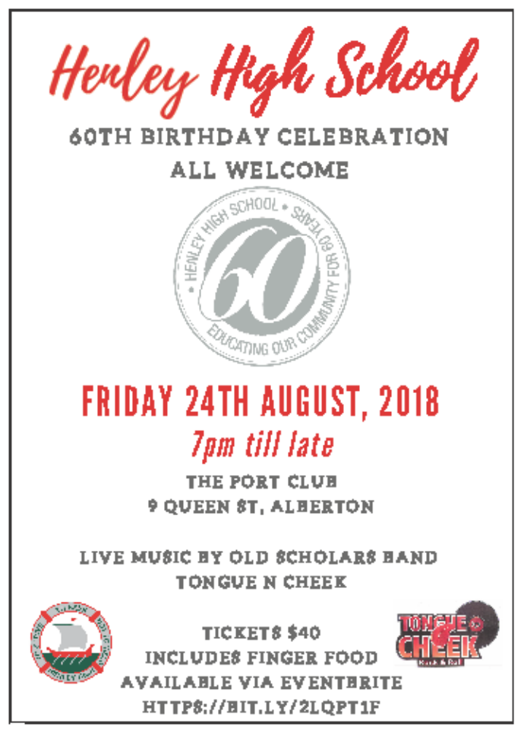Perfect conditions for school footy on Saturday, the sun was out and the boys were up and about and ready to play. St Michaels Blue played a competitive game, but in the end were beaten by the Mighty Owls who’s attack on the loose ball and delivery into the forward line won the day. Special mentions this week to Giuseppe Tropeano who played a blistering game on ball and kicked three. Max Voller played a competitive quarter for St Michaels. Archie Marshall contested the loose ball and was busy in the forward line. Toby Clogg provided run and marked everything in the midfield. Will McMahon proved once again that he is a talented goal sneak with a snap on goal under pressure.
Goal scorers: Giuseppe Tropeano, Leo Treadrea, Archie Marshall, Bastien Loveder, Jye Linke, Logan Stephens, Will McMahon.
Best Players: Giuseppe Tropeano, Toby Clogg, Archie Marshall.

Year 4/5
22/6/18
Fulham North 8.4.52 defeated by Star of the Sea Gold 10.8.66.
Best Players – Tyson Pope, Kobe Curness & Dylan Turner.
Goal Scorers – Tyson Pope 2 and 1 each to Leon Fazzalari, Ethan Matthews, Cohen Stephens, Jack Trotter, Kobe Curness, Nate Tredrea and Dylan Turner.
A good lesson for the young owls this week, tasting their first defeat of the year at the hands of Star of the Sea. From the outset the opposition hunted the ball and were very strong in their attack on the body as well. Tyson Pope had his best game for the school kicking two great goals. Kobe Curness kicked a nice goal and was lively in the forward line. Dylan Turner battled hard all day in the middle.

COMMUNITY NEWS
ENTERTAINMENT BOOKS
Once again, Fulham North will be selling Entertainment books as part of our fundraising efforts for the year. Books are now available from the Front Office or you can purchase a digital version. Cost is $70 per book.
You can order your membership from us at https://www.entertainmentbook.com.au/orderbooks/161073h

SCHOOL DENTAL
The School Dental Service is a Child Dental Benefits Schedule provider. Call us now for an appointment!
www.sahealth.sa.gov.au/sadental SA Dental Service
Keep your kids smiling
Dental care is FREE for ALL babies, preschool and most children under 18 years at School Dental Service clinics.
The School Dental Service is a Child Dental Benefits Schedule provider.
Call us now for an appointment!
Your local clinic is: Fulham Gardens School Dental Clinic
Phone: 8356 8394 www.sahealth.sa.gov.au/sadental

WEST TORRENS DISTRICT CRICKET CLUB
Junior Premier League Trials Season 2018/19. Trial dates 12 and 19 August 2018. U14, U16 as at 1/9/18. For information re. times, email juniors@westerneagles.com

